Using Topaz DeNoise AI for noise (and sharpening.)

First up – I am lousy at applying sharpening and noise reduction, especially in Lightroom. It seems too easy to tweak the noise from smooth to cartoon (it does not seem linear, you make a big move and nothing happens, then you make a tiny one and it’s all Huckleberry Hound!).
Sharpening is a bit the same; nothing happens for a while then then there are more haloes than a Giotto!
The problem with the Canon 7D was that once ISO’s went above 800 then noise became a problem.
I looked at all sorts of solutions and have ended up using Topaz DeNoise AI. I will admit that I began with Topaz DeNoise, but that was just as confusing as any other application – with the same results. But when I got an upgrade to DeNoise AI it is a lot easier and frankly -it suits me.I really do not want to be mucking around de noising things when I can be doing other things.
The advice from Topaz is to use this at the start of your workflow, because it could introduce artefacts if you use it at the end of your workflow due to the adjustments you may have made. Despite this, I tend to use it at the end and I have not seen the problems warned by Topaz.
DeNoise AI operates as a plug in to Photoshop and Lightroom as well as being stand alone. You can save the files in a variety of formats –I tend to save mine in TIFF
Firstly the interface is dead easy – for me that is an immediate winner. There is the choice of two algorithms. Denoise AI and AI Clear. AI Clear is an earlier algorithm and in some cases gives better results then DeNoise AI (No I have not systematically looked at it, I just click save when the result pleases my eye)
When you open the photo in DeNoise AI it puts a base Denoise AI setting of 15 for Noise and 15 for Sharpening. You can then use Denoise in Auto, or AI Clear in Auto. The Auto settings are a good starting point and can be manually changed to taste at any time. .– DeNoise AI uses a Slider while AI Clear uses buttons of High, Medium and Low.
To be honest I don’t know how the AI bit works but I do know that for me it is easy and gives good results – certainly better than I have ever got by any other method.
My workflow is:
Upload photos to Lightroom applying zero sharpening, make any Lightroom adjustments
Go to Photoshop, do any changes (Photoshop is better at cloning and repairing images than Lightroom). If I have been using multiple layers I merge into a flattened layer at the top of the stack with Control Alt shift E, then pen the filters dialogue and select DeNoise AI. If there are no adjustments in Photoshop I simply make a duplicate layer and then go into DeNoise AI.
Denoise AI comes up with an enlarged split screen of the Photo. Navigating the enlarged view to a key part of the image, I move the before and after line back and forth a bit as I make changes. I have a look at the default, then the Denoise AI auto and the AI Clear auto, see which one suits the photo best, do any minor adjustments, select OK. You can apply to the whole image or brush where you want
There is a bit of crunching and you’re back in Photoshop, save back into Lightroom as a Tiff. Both the AI autos tend to put more emphasis on sharpening that reducing noise. It also comes with a nice start up dialogue
For me it is simple, easy and works. As a worked example I am using an astro shot taken with the Canon 7D at ISO 1600, 20 Seconds, f2.8 with a Tamron 15-30 lens at 15mm at Lake Bolac a couple of years ago.
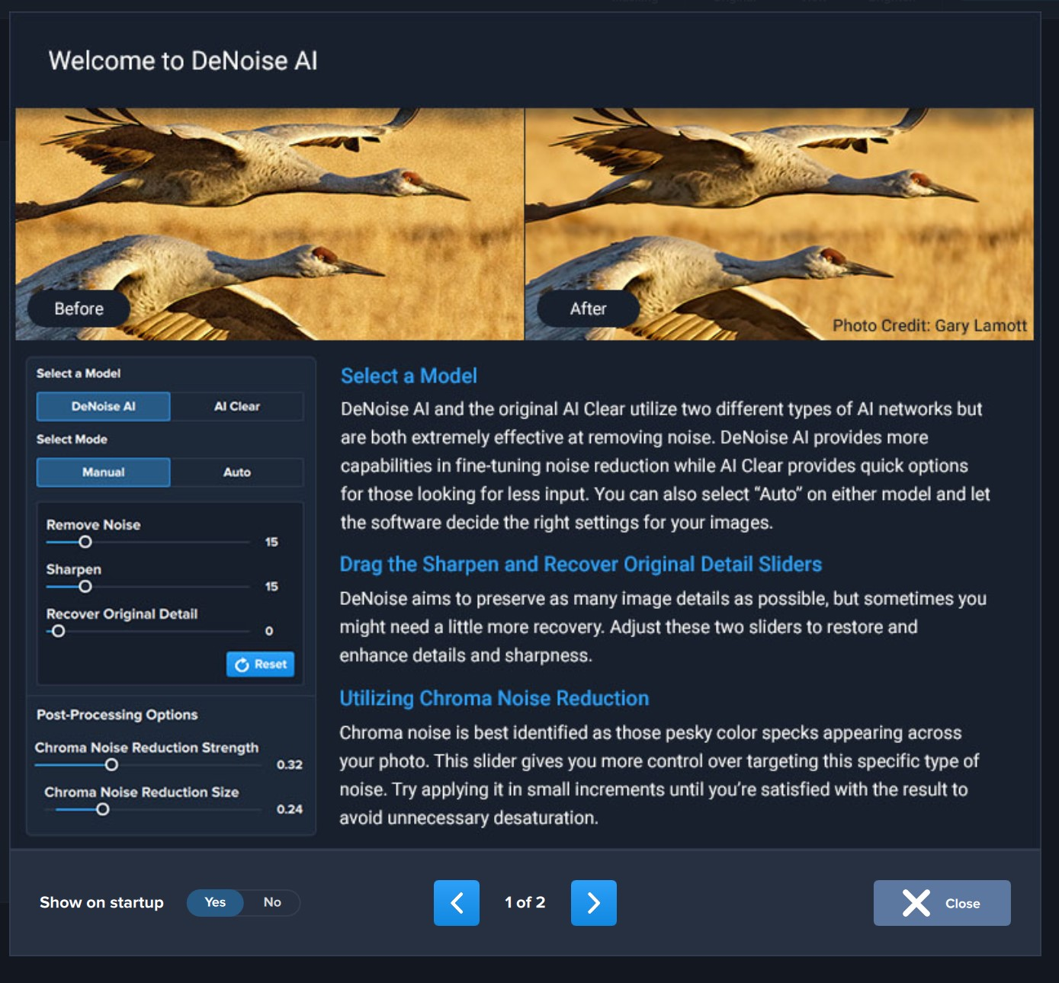
(01 DeNoise AI Opening Splash Screen 1.jpg)
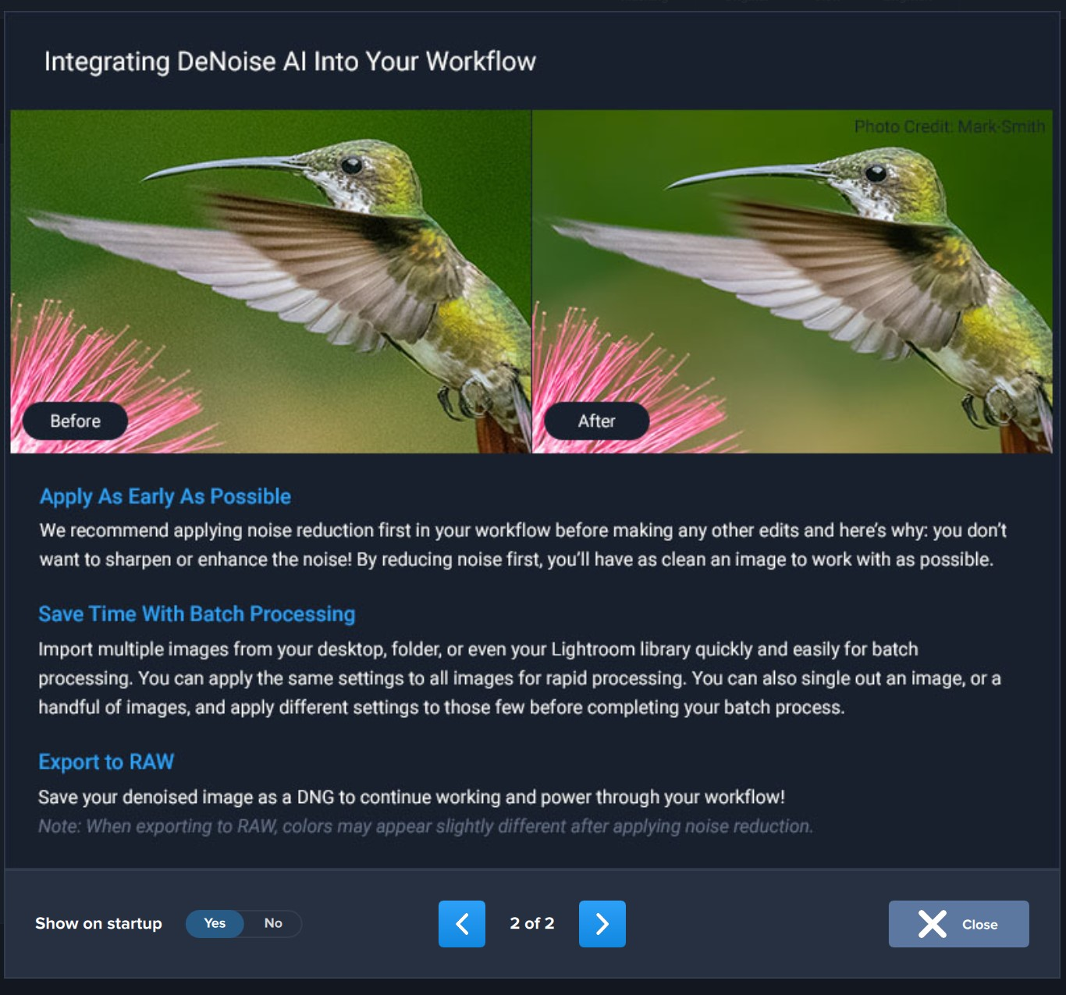
(02 DeNoise AI Opening Splash Screen 2.jpg)
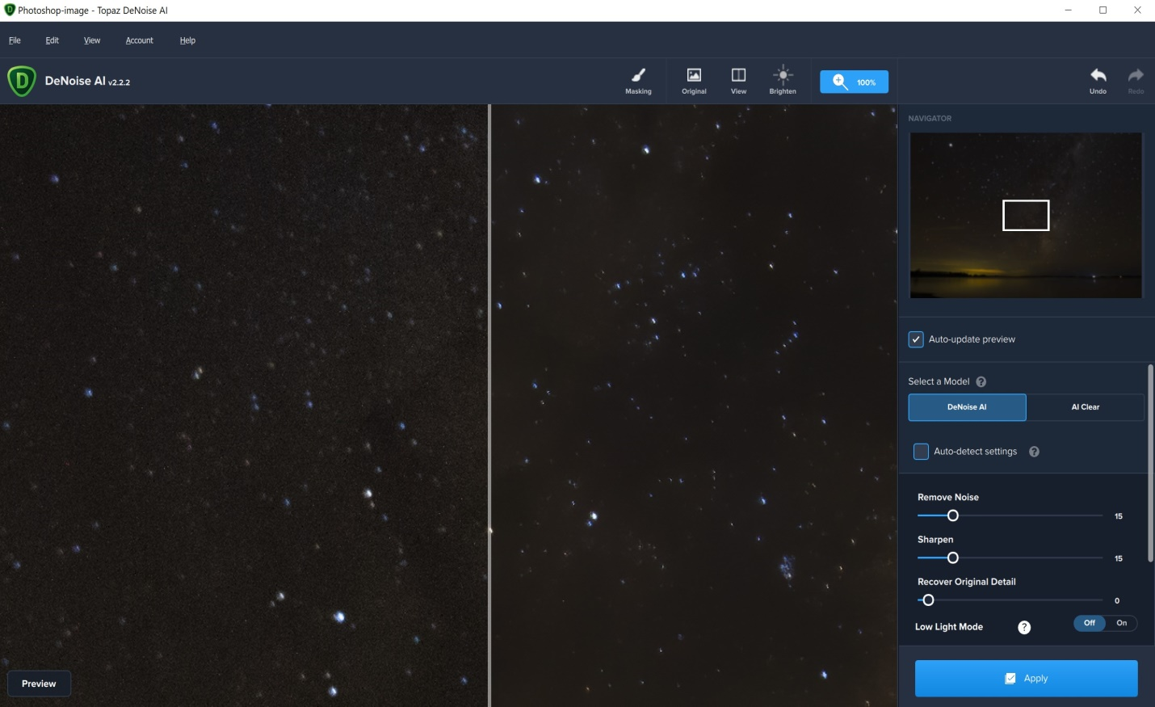
Opening preview with default Denoise AI noise =15 and sharpen = 15 (03 Default Denoise AI_Astro.jpg). Note that the original is on the left of the view, the treated part is on the right.
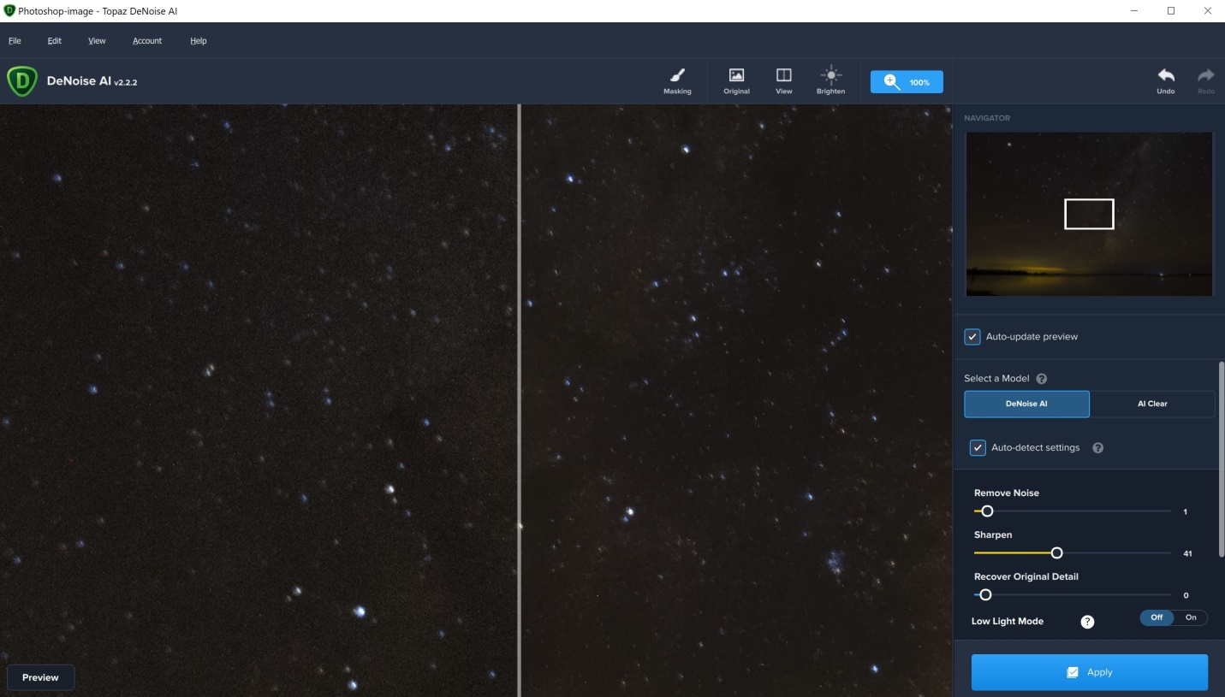
DeNoise AI Auto (04 Denoise AI Auto_Astro.jpg). Note that the original is on the left of the view, the treated part is on the right.

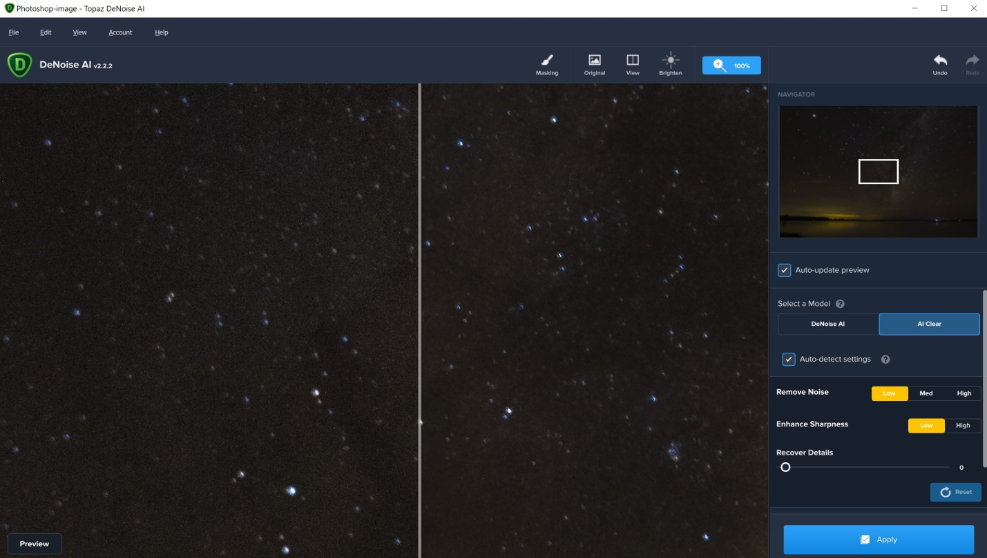
Same Pic in AI Clear Auto (05 AI Clear Auto_Astro.jpg). Note that the original is on the left of the view, the treated part is on the right.
In this case I went for the default with a shade more sharpening.

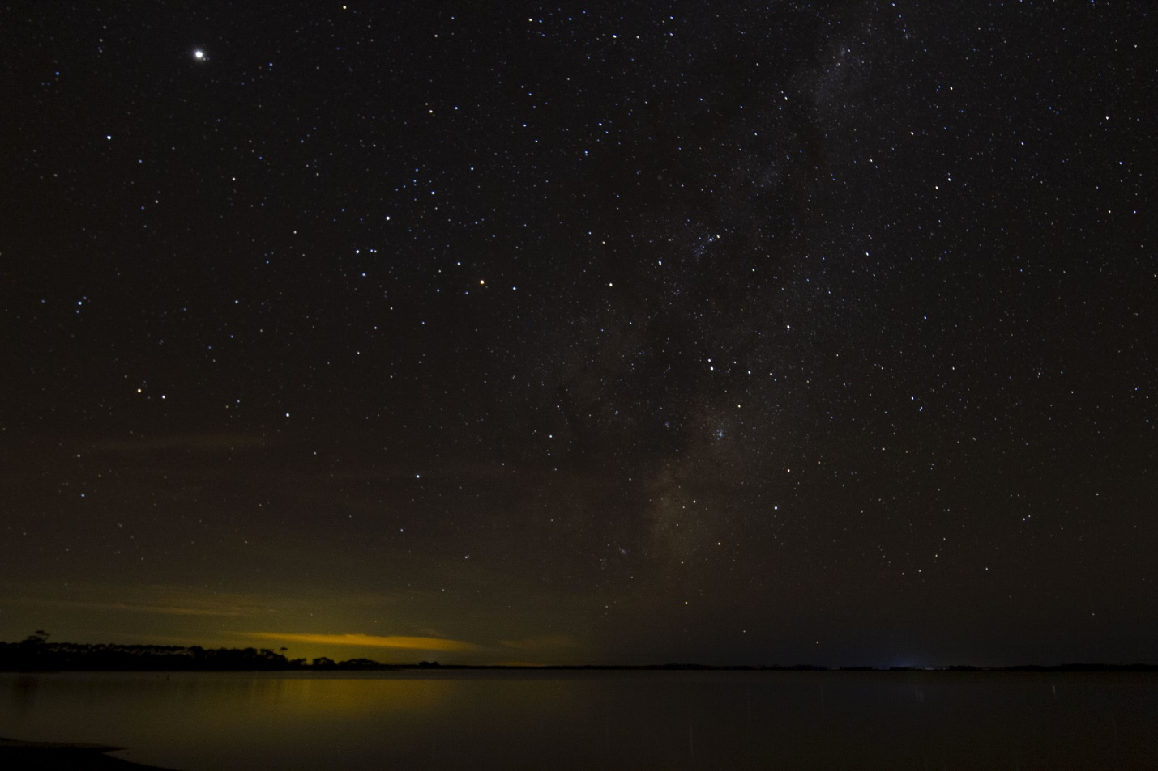
Original image in Lightroom (06 _IMG_1103.jpg)
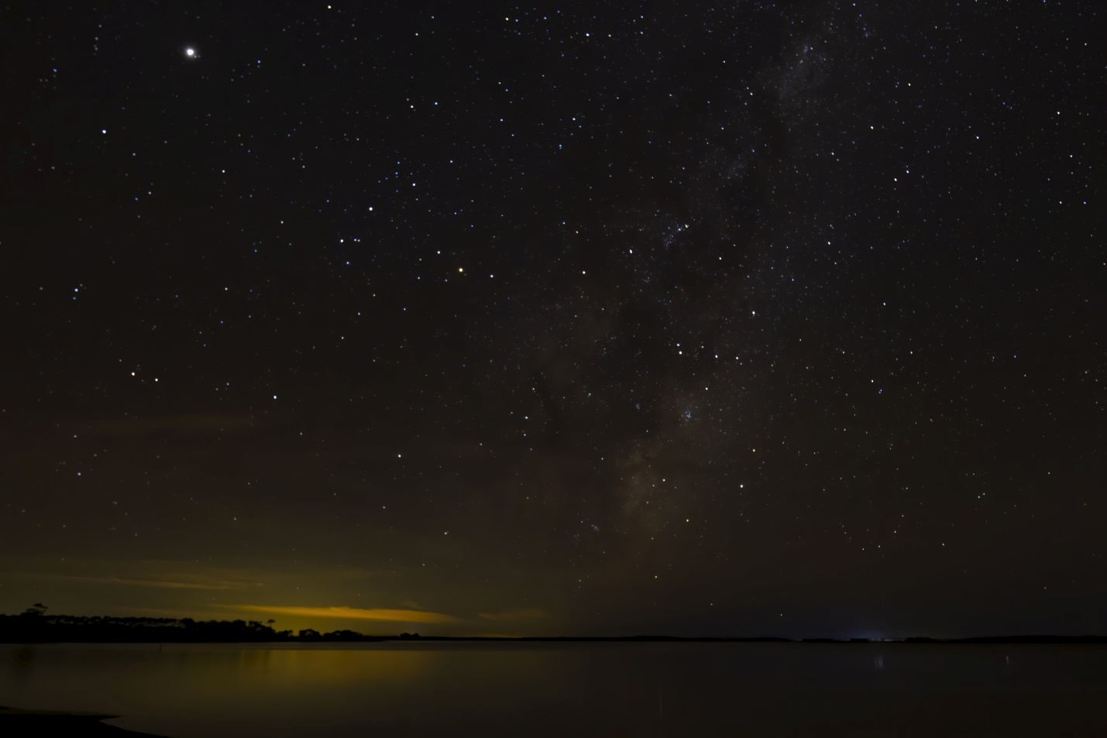
After DeNoise(07_IMG_1103-Edited.jpg)
When enlarged to full screen, to mem the edited version is much clearer.

